Offline 7
Name : Md Sabbir Rahman
Roll : 1705076
Section : B1
Course : CSE 204, Data Structure and Algorithms Sessional
Submission Date : 27-07-2019

Objective: The objective is to run merge sort and quick sort on arrays of different sizes and compare their worst case, best case and average case runtime.

Machine Specs: Intel Core i5-4460 CPU @ 3.20 GHz, 8.00 GB, x64 based processor. Windows 8.1 Operating System.

Data: In the enclosed cpp file, Merge sort and Quick sort were implemented and run on randomly generated array of various sizes .For average case, a random array was taken, for worst case, a reverse sorted array was generated, for best case a sorted array was generated. The execution time has been added as a excel file with the report. We notice that for merge sort all cases show similar times. But for quick sort, the running time becomes quadratic in worst and best case. Otherwise quick sort always beats merge sort.
 |  | time (microseconds)
CASE | SORT | 10 | 50 | 100 | 500 | 1000 | 5000 | 10000
Best | Merge | 10.32 | 62.48 | 127.33 | 299.31 | 558.15 | 1402.34 | 2547.71
Best | Quick | 0.89 | 12.71 | 44.26 | 522.17 | 2060.76 | 24260.9 | 94521.2
Worst | Merge | 9.87 | 60.11 | 92.05 | 346.46 | 559.51 | 1237.87 | 2691.15
Worst | Quick | 1.15 | 15.26 | 37.07 | 771.71 | 2553.55 | 28204.8 | 114965
Average | Merge | 11.09 | 63.57 | 69.02 | 315.224 | 615.18 | 1488.24 | 3036.2
Average | Quick | 1.79 | 10.71 | 12.76 | 82.43 | 162.61 | 478.482 | 1085.26

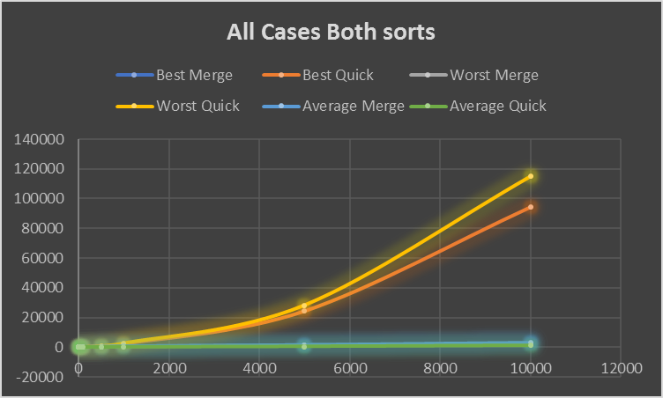
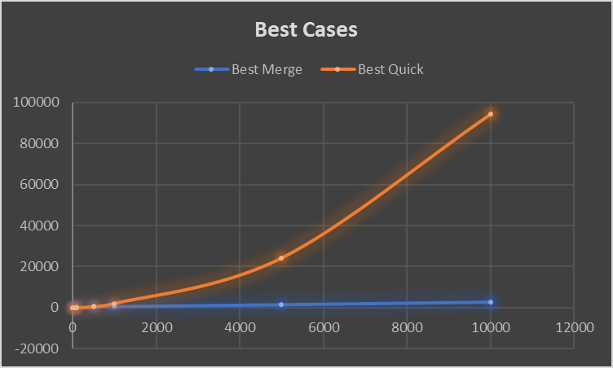

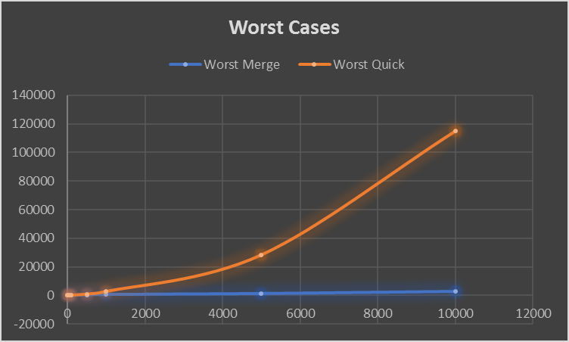
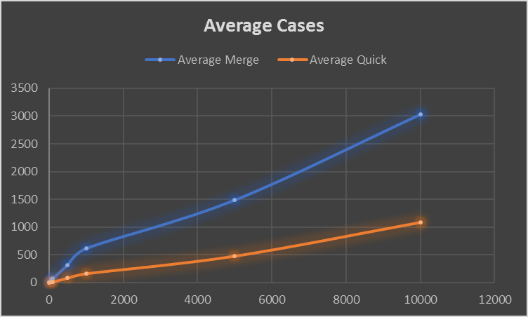

Complexity Analysis: For merge sort, the running time recurrence is T(n) = T(n/2) + O(n) . Applying master theorem, we get T(n) = O(nlog n).
For quick sort, the running time recurrence is T(n) = T(p) + T(n-p-1) + O(n) where p is length of first partition. In average case, p = n/2 and so T(n) = O(nlog n) like merge sort. In worst and best case, p is always 1 and n-1 and we get T(n) = T(1) + T(n-2) + O(n), which gives T(n) = O(n^2) time.
Discussion: The running time were measured by using windows’ QueryPerformanceCounter function which is very accurate. The time was measured before and after calling the sort functions on copied arrays to only measure execution time of the function. The quick sort couldn’t be called on bigger arrays due to stack overflow happening in worst case.

